Wireless Patient Heartbeat and Temperature monitoring system

Introduction

Recently, the health care sensors are playing a vital role in hospitals. The patient monitoring systems is one of the major improvements because of its advanced technology. A wireless patient monitoring system to measure heartbeat and body temperature of the patient by using embedded technology is developed.

So we are here, just connecting the temperature sensor and heartbeat sensor so that simultaneously we can monitor the patient’s condition and hence ruling out the use of the thermometer and other devices to check the condition of the patient.

This information i.e. the Heart Rate & the Body Temperature is then transmitted wirelessly to the doctor which in not in the vicinity of the patient through GSM technique. The sensors measure the information and transmit it through GSM Modem on the same frequency as on which cell phones work.

Block Diagram
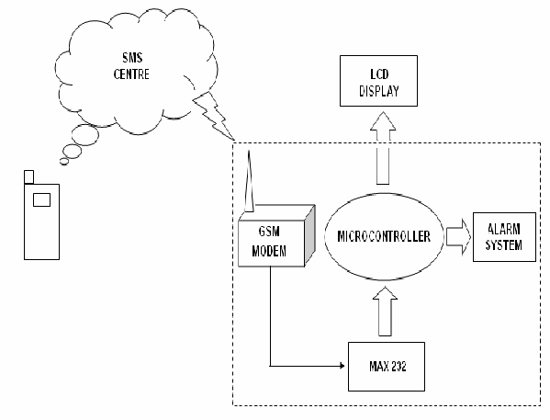

Temperature Sensor
LCD Display

Patient Monitor
Software
Arduino Uno
(Microcontroller Unit)

Heart beat monitor Module
GSM Module for SMS to Doctor

Working principle

The block diagram of the patient monitoring system is shown in above Fig.

The 2 sensor modules (Temperature sensor and Heart Beat monitoring module) read the data from patient’s body and send it to the Arduino Controller unit.

The C program running inside the Arduino will get the values from the Sensor modules and calculate the values for critical point.

The Values are then sent to the doctor through the GSM Module as SMS with data of temperature and Heartbeat of the patient.

Components Used

The Major Components used in Our Project are:

- MICROCONTROLLER Unit Arduino
- MAX 232
- LCD DISPLAY
- ADC CONVERTER
- LM35 ( TEMPERATURE SENSOR)
- SIM 300 GSM MODEM
- CRYSTAL 11.0592 MHz
- BUZZER
- CAPACITORS
- RESISTORS
- CONNECTING WIRES
- POWER SUPPLY
- 7805 voltage regulator
- PCB
- Battery/ Power Supply
- Other discrete components.

Software

The software for this project will be written in C on Arduino IDE.

Description of major components

Arduino UNO

Arduino is a single-board microcontroller, intended to make it easier to build interactive objects or environments. The hardware consists of an open-source hardware board designed around an 8-bit Atmel AVR microcontroller, or a 32-bit Atmel ARM. Current models feature a USB interface, 6 analog input pins, as well as 14 digital I/O pins that accommodate various extension boards.

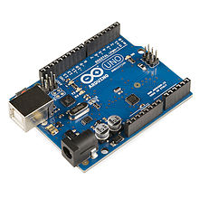

Heart Beat Monitor Module

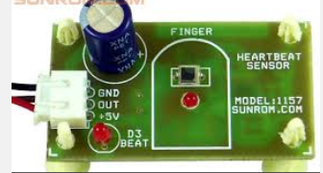

Heart beat sensor is designed to give digital output of heat beat when a finger is placed on it. When the heart beat detector is working, the beat LED flashes in unison with each heart beat. This digital output can be connected to microcontroller directly to measure the Beats Per Minute (BPM) rate. It works on the principle of light modulation by blood flow through finger at each pulse.

Features
Microcontroller based SMD design
Heat beat indication by LED
Instant output digital signal for directly connecting to microcontroller
Compact Size
Working Voltage +5V DC

Applications
Digital Heart Rate monitor
Patient Monitoring System
Bio-Feedback control of robotics and applications

GSM Module

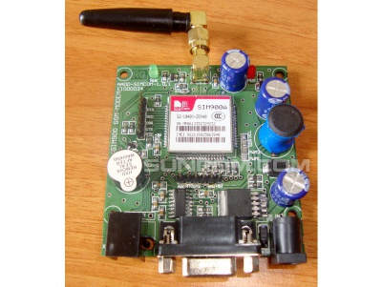

This GSM Modem can accept any GSM network operator SIM card and act just like a mobile phone with its own unique phone number. Advantage of using this modem will be that you can use its RS232 port to communicate and develop embedded applications. Applications like SMS Control, data transfer, remote control and logging can be developed easily.
The modem can either be connected to PC serial port directly or to any microcontroller through MAX232. It can be used to send and receive SMS or make/receive voice calls. It can also be used in GPRS mode to connect to internet and do many applications for data logging and control. In GPRS mode you can also connect to any remote FTP server and upload files for data logging.
This GSM modem is a highly flexible plug and play quad band SIM300AGSM modem for direct and easy integration to RS232 applications. Supports features like Voice, SMS, Data/Fax, GPRS and integrated TCP/IP stack.

LM35

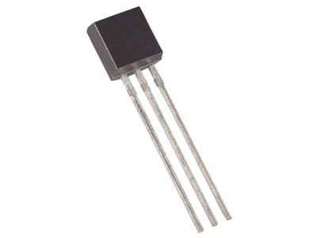

Outputs 10mV per Degree that can also be read directly on multimeter or read in to microcontroller. For example at 30 degree celcius it will output 300mV at linear scale.
The LM35 series are precision integrated-circuit temperature sensors, whose output voltage is linearly proportional to the Celsius (Centigrade) temperature. The LM35 thus has an advantage over linear temperature sensors calibrated in ° Kelvin, as the user is not required to subtract a large constant voltage from its output to obtain convenient Centigrade scaling. The LM35 does not require any external calibration or trimming to provide typical accuracies of ±¼°C at room temperature and ±¾°C over a full -55 to +150°C temperature range. Low cost is assured by trimming and calibration at the wafer level. The LM35's low output impedance, linear output, and precise inherent calibration make interfacing to readout or control circuitry especially easy. It can be used with single power supplies, or with plus and minus supplies. As it draws only 60 µA from its supply, it has very low self-heating, less than 0.1°C in still air. The LM35D is rated to operate over a 0° to +100°C temperature range.

